Team Around the Family Closure Summary

Date of closure |  |  | Date TAF started |  | Date of last review
Name of Child | Date of Birth | Does the child have a disability? |  | Did the child attend the meeting? |  | Name of the parent/ carer with PR
Name of the lead professional and contact details

Team attending todays review
Name | Role/Agency | Contact details | Invited? | Attended?

Original reason for opening TAF

Reason for Closing TAF.

Closure Summary Please select the overall reason for Team Around the family closure | Yes/No | Comments  How will the family continue to support the child? | Family Agreement
Team Around the Family closed due to all needs being met.
Team Around the Family closed due to most needs being met and a single agency will continue support
Team Around the Family closed due to ‘step up’ to Social Care
Team Around the Family closed due to family moving out of the area
Team Around the Family closed due to child or family withdrawing consent
Team Around the Family closed for another reason (please specify)

Final Scaling
TAF  Member's Scaling. | 0 1 2 3 4 5 6 7 8 9 10
0 = We have not been able to meet the child/young person's needs.  If any member of the TAF scales at a 0 please contact your Early Help link worker immediately for support prior to submitting the closure summary TAF@nelincs.gov.uk |  |  |  |  |  |  | 10 = We are so pleased that this child's family and safety network are now confidently managing their child's needs without any specific support.  The child and young person feels listened to and supported. Any issues have been effectively dealt with, and the TAF has been very effective. The outcomes for the child/young person are excellent, and sustainable.

How effective has the Team Around the Family been in improving life for you?
How do you feel as your TAF closes?  What's changed?  What has been the best part of this?  What has been the worst part?  How did the Lead Professional and your family make sure you were a strong part of the TAF? | Did it do what you needed it to do?  Is there anything you would have liked to have been different? Why?  What will you take with you as you move forward?  What help do you need to make this happen?
Child/Young Person’s Views

How effective has the Team Around the Family been in improving life for your child/young person?
- What's changed through working with the TAF? How has this made a difference to your child and family?  - What would you say was the one thing that made the biggest impact on your child and family? | - How did the TAF journey feel for you and your family? What would you want to change, why?  - What will you take forward with you to build on the progress, once the TAF has closed?  - Would you recommend Team Around the Family to someone else? Why?
Parent(s)’/Carer(s)’ Views
How effective has the Team Around the Family been in improving life for this child/young person?
- What has changed for the child/young person and their family through their TAF? How do you know?  - What barriers, if any have you found in this TAF in making a difference for the child/young person? How can these continue to be overcome as TAF closes to sustain progress for the child? | - What would you say was the most powerful part to the success of this TAF?  - Lead Professional, did you access support from an Early Help link worker in your role?
Professionals’ Views

How we measure impact (Please select below if you feel success has been achieved in the following areas)
☐Getting a good Education ☐Children safe from Abuse and Exploitation
☐Good early years development ☐Crime prevention and tackling crime
☐Improved mental and physical health ☐Safe from domestic abuse
☐Promoting recovery and reducing harm from substance use ☐Secure housing
☐Improved family relationships ☐Financial stability
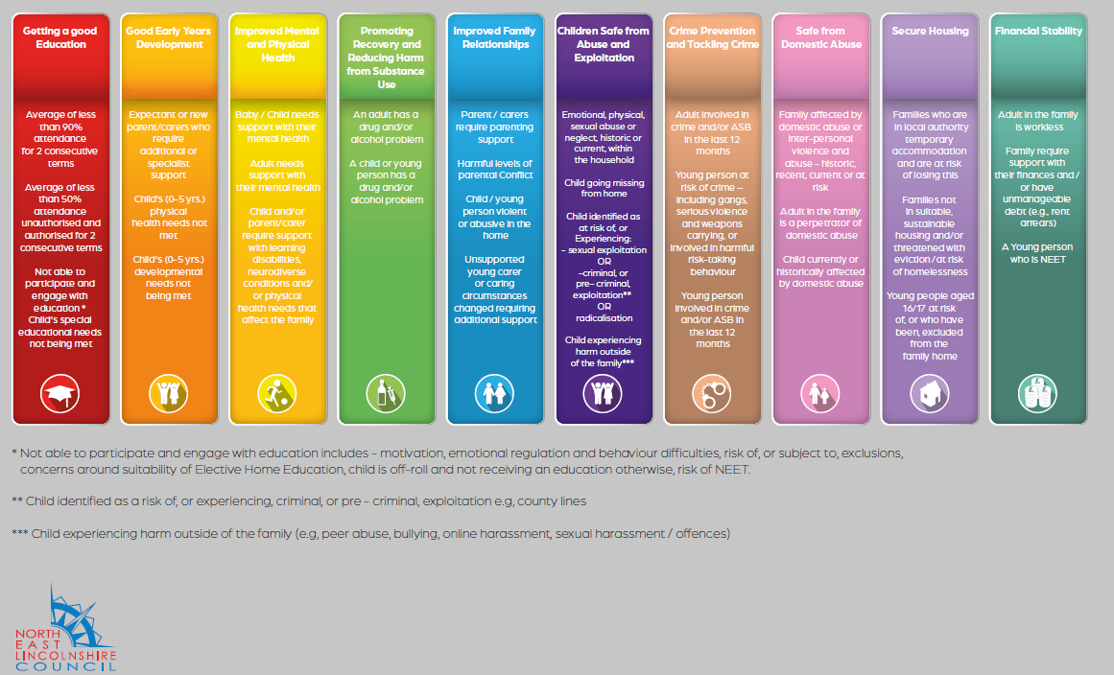

Closure Agreement

(Please use the Child and Family Progress Plan, where appropriate)

Child | Parent/carer | Lead Professional
Signature | Signature | Signature
Date | Date | Date

